**SUPPLEMENTAL MATERIALS**

**Associations of per- and polyfluoroalkyl substances (PFAS) with glucose tolerance during pregnancy in the Project Viva cohort**

Emma V. Preston1, Sheryl L. Rifas-Shiman2, Marie-France Hivert2,3, Ami R. Zota4, Sharon K. Sagiv5, Antonia M. Calafat6, Emily Oken2, Tamarra James-Todd1,7

1Department of Environmental Health, Harvard T.H. Chan School of Public Health, Boston, MA, United States

2Department of Population Medicine, Harvard Medical School and Harvard Pilgrim Health Care Institute, Boston, MA, United States

3Diabetes Unit, Massachusetts General Hospital, Boston, MA

4Department of Environmental and Occupational Health, Milken Institute School of Public Health, George Washington University, Washington, DC, United States

5Center for Environmental Research and Children’s Health (CERCH), School of Public Health, University of California at Berkeley, Berkeley, CA

6U.S. Centers for Disease Control and Prevention, Atlanta, GA, United States

7Department of Epidemiology, Harvard T.H. Chan School of Public Health, Boston, MA United States

**Table of Contents:**

**Table S1.** Distributions of plasma PFAS concentrations (ng/mL) measured during early pregnancy (median 9.7 weeks) in the study population (n=1,540) in 1999-2002..........................2

**Table S2.** Adjusteda ORs (95% CIs) for categories of glucose tolerance per unit increase in plasma ln-PFAS concentration (n=1,540)……………………………………………………………………………………3

**Table S3.** BKMR estimated effects of individual PFAS concentrations on blood glucose levels (mg/dL) 1-hour post 50-g non-fasting GCT (n=1,530)…………………………………………………………………4

**Table S4.** Multivariate-adjusted difference in blood glucose levels (mg/dL) from second-trimester 50-g non-fasting GLT across serum PFAS quartiles, overall and stratified by pre-pregnancy BMI (<25, ≥25 kg/m2)………………………………………………………………………………………………..5

**Figure S1.** Spearman correlation coefficient matrix for plasma PFAS concentrations measured during early pregnancy (n=1,540)………………………………………………………………………………………………6

**Figure S2.** Combined effects of the PFAS mixture on blood glucose levels (n=1,533) estimated by Bayesian Kernel Machine Regression (BKMR)…………………………………………………………………………….7

|  |  |  |  |  |  |  |  |
| --- | --- | --- | --- | --- | --- | --- | --- |
| **Table S1.** Distributions of plasma PFAS concentrations (ng/mL) measured during early pregnancy (median 9.7 weeks) in the study population (n=1,540) in 1999-2002. | | | | | | | |
| **PFAS** | **% detection** | **GM (GSD)** | **Min** | **25%** | **50%** | **75%** | **Max** |
| PFOS | 99.9 | 25.5 (1.7) | <LOD | 18.8 | 25.7 | 34.9 | 185.0 |
| PFOA | 100 | 5.7 (1.6) | 0.3 | 4.2 | 5.9 | 7.9 | 36.7 |
| PFHxS | 99.3 | 2.5 (2.1) | <LOD | 1.6 | 2.5 | 3.8 | 74.5 |
| PFNA | 98.6 | 0.6 (1.7) | <LOD | 0.5 | 0.7 | 0.9 | 6.0 |
| EtFOSAA | 99.7 | 1.2 (2.1) | <LOD | 0.7 | 1.2 | 1.9 | 33.6 |
| MeFOSAA | 100 | 1.9 (2.0) | <LOD | 1.3 | 1.9 | 3.2 | 29.7 |

Abbreviations: GM, geometric mean; GSD, geometric standard deviation; PFAS, per- and polyfluoroalkyl substances; PFOS, perfluorooctane sulfonate; PFOA, perfluorooctanoate; PFHxS, perfluorohexane sulfonate; PFNA, perfluorononanoate; EtFOSAA, 2-(N-ethyl-perfluorooctane sulfonamide) acetate; MeFOSAA, 2-(N-methyl-perfluorooctane sulfonamide) acetate.

Limits of detection: PFOS= 0.2 ng/mL, all other PFAS= 0.1 ng/mL

|  |  |  |  |  |
| --- | --- | --- | --- | --- |
| **Table S2.** Adjusteda ORs (95% CIs) for categories of glucose tolerance per unit increase in plasma ln-PFAS concentration (n=1,540) | | | | |
| **PFAS** | **Normal (n=1,284)** | **IH (n=126)** | **IGT (n=45)** | **GDM (n=85)** |
| lnPFOS | 1 (Ref) | 0.9 (0.6, 1.2) | 1.0 (0.5, 1.7) | 1.3 (0.8, 2.1) |
| lnPFOA | 1 (Ref) | 1.0 (0.7, 1.5) | 0.9 (0.5, 1.6) | 1.0 (0.6, 1.6) |
| lnPFHxS | 1 (Ref) | 1.2 (0.9, 1.6) | 0.8 (0.6, 1.3) | 0.9 (0.6, 1.3) |
| lnPFNA | 1 (Ref) | 1.2 (0.8, 1.7) | 1.1 (0.6, 2.0) | 0.9 (0.6, 1.5) |
| lnEtFOSAA | 1 (Ref) | 0.9 (0.7, 1.1) | 1.2 (0.8, 1.8) | 1.3 (0.9, 1.8) |
| lnMeFOSAA | 1 (Ref) | 1.0 (0.8, 1.4) | 1.0 (0.6, 1.6) | 1.1 (0.8, 1.7) |
| Abbreviations: PFAS, per- and polyfluoroalkyl substances; IH, isolated hyperglycemia, IGT, impaired glucose tolerance; GDM, gestational diabetes mellitus; PFOS, perfluorooctane sulfonate; PFOA, perfluorooctanoate; PFHxS, perfluorohexane sulfonate; PFNA, perfluorononanoate; EtFOSAA, 2-(N-ethyl-perfluorooctane sulfonamide) acetate; MeFOSAA, 2-(N-methyl-perfluorooctane sulfonamide) acetate.  aAdjusted for maternal age (continuous), pre-pregnancy BMI (continuous), prior history of GDM/parity, race/ethnicity, smoking, education | | | | |
|

**Table S3.** BKMR estimated effects of individual PFAS concentrations on blood glucose levels (mg/dL) 1-hour post 50-g non-fasting GCT (n=1,530)

|  |  |
| --- | --- |
| **PFAS** | **Beta (95% CI)a** |
| PFOS | 6.2 (1.1, 11.3) |
| PFOA | -0.7 (-4.8, 3.3) |
| PFHxS | -0.3 (-1.9, 1.4) |
| PFNA | -0.2 (-3.1, 2.7) |
| EtFOSAA | -0.7 (-3.7, 2.3) |
| MeFOSAA | -0.4 (-4.3, 3.5) |

Abbreviations: PFAS, per- and polyfluoroalkyl substances; IH, isolated hyperglycemia, IGT, impaired glucose tolerance; GDM, gestational diabetes mellitus; PFOS, perfluorooctane sulfonate; PFOA, perfluorooctanoate; PFHxS, perfluorohexane sulfonate; PFNA, perfluorononanoate; EtFOSAA, 2-(N-ethyl-perfluorooctane sulfonamide) acetate; MeFOSAA, 2-(N-methyl-perfluorooctane sulfonamide) acetate.

a Beta estimates represent differences in glucose levels (mg/dl) for a change in individual PFAS concentration from the 25th to 75th percentile, holding all other PFAS at their median concentrations.

Adjusted for maternal age (continuous), pre-pregnancy BMI (continuous), prior history of GDM/parity, race/ethnicity, smoking, education.

|  |  |  |  |  |
| --- | --- | --- | --- | --- |
| **Table S4.** Multivariate-adjusteda difference in blood glucose levels (mg/dL) from second-trimester 50-g non-fasting GLT across serum PFAS quartiles, overall and stratified by pre-pregnancy BMI (<25, ≥25 kg/m2) | | | | |
|  |  | **Overall cohort (n=1,533)** | **BMI <25 kg/m2 (n=948)** | **BMI ≥ 25 kg/m2 (n=585)** |
| **PFAS** |  | **Beta (95% CI)** | **Beta (95% CI)** | **Beta (95% CI)** |
| PFOS | Q1 | 0 (Ref) | 0 (ref) | 0 (ref) |
|  | Q2 | 2.40 (-1.24, 6.04) | 2.48 (-1.86, 6.82) | 2.98 (-3.57, 9.53) |
|  | Q3 | 3.71 (0.01, 7.42) | 4.63 (0.11, 9.14) | 3.52 (-2.84, 9.88) |
|  | Q4 | 4.27 (0.55, 7.98) | 2.90 (-1.63, 7.42) | 6.35 (-0.10, 12.79) |
| PFOA | Q1 | 0 (Ref) | 0 (Ref) | 0 (Ref) |
|  | Q2 | -0.39 (-4.05, 3.27) | 0.77 (-3.66, 5.20) | -0.24 (-6.67, 6.20) |
|  | Q3 | 1.00 (-2.81, 4.81) | 1.20 (-3.44, 5.83) | 2.74 (-3.89, 9.37) |
|  | Q4 | 1.47 (-2.37, 5.30) | 1.80 (-3.02, 6.61) | 2.06 (-4.31, 8.42) |
| PFHxS | Q1 | 0 (Ref) | 0 (Ref) | 0 (Ref) |
|  | Q2 | -0.65 (-4.34, 3.03) | -0.95 (-5.46, 3.56) | -0.99 (-6.69, 4.71) |
|  | Q3 | 1.89 (-1.77, 5.55) | -0.10 (-4.56, 4.36) | -0.96 (-7.88, 5.96) |
|  | Q4 | 1.17 (-2.62, 4.96) | -0.37 (-4.92, 4.17) | -0.04 (-6.46, 6.39) |
| PFNA | Q1 | 0 (Ref) | 0 (Ref) | 0 (Ref) |
|  | Q2 | -0.88 (-4.22, 2.46) | -0.54 (-4.68, 3.59) | -0.99 (-6.69, 4.71) |
|  | Q3 | 1.13 (-2.81, 5.07) | 1.93 (-2.87, 6.73) | -0.96 (-7.88, 5.96) |
|  | Q4 | 0.78 (-2.84, 4.41) | 1.49 (-2.88, 5.86) | -0.04 (-6.46, 6.39) |
| EtFOSAA | Q1 | 0 (Ref) | 0 (Ref) | 0 (Ref) |
|  | Q2 | -1.86 (-5.42, 1.70) | -2.72 (-6.99, 1.56) | -0.55 (-6.89, 5.79) |
|  | Q3 | 1.67 (-2.04, 5.37) | 1.65 (-2.81, 6.10) | 1.45 (-5.16, 8.06) |
|  | Q4 | 0.35 (-3.39, 4.10) | 0.43 (-4.12, 4.98) | 0.20 (-6.32, 6.72) |
| MeFOSAA | Q1 | 0 (Ref) | 0 (Ref) | 0 (Ref) |
|  | Q2 | 5.77 (2.08, 9.45) | 5.16 (0.64, 9.67) | 6.96 (0.63, 13.29) |
|  | Q3 | 2.41 (-1.10, 5.92) | 3.49 (-0.77, 7.76) | 0.96 (-5.17, 7.08) |
|  | Q4 | 2.72 (-0.97, 6.40) | 3.12 (-1.32, 7.55) | 1.79 (-4.75, 8.33) |
| aAdjusted for maternal age (continuous), prior history of GDM, race/ethnicity, smoking, education  Cross-product interaction term p-values: PFOS=0.51, PFOA=0.70, PFHxS=0.19, PFNA=0.99, EtFOSAA=0.88, MeFOSAA=0.65 | | | | | |
|
|

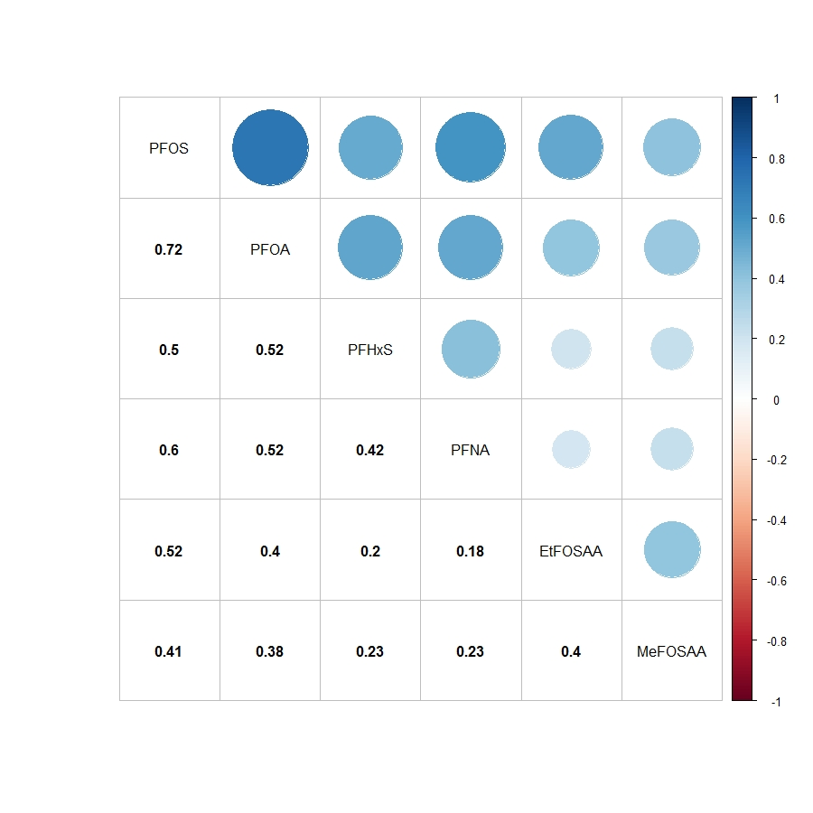

**Figure S1.** Spearman correlation coefficient matrix for plasma PFAS concentrations measured during early pregnancy (n=1,540). All p-values <0.0001. Abbreviations: PFAS, per- and polyfluoroalkyl substances; PFOS, perfluorooctane sulfonate; PFOA, perfluorooctanoate; PFHxS, perfluorohexane sulfonate; PFNA, perfluorononanoate; EtFOSAA, 2-(N-ethyl-perfluorooctane sulfonamide) acetate; MeFOSAA, 2-(N-methyl-perfluorooctane sulfonamide) acetate.

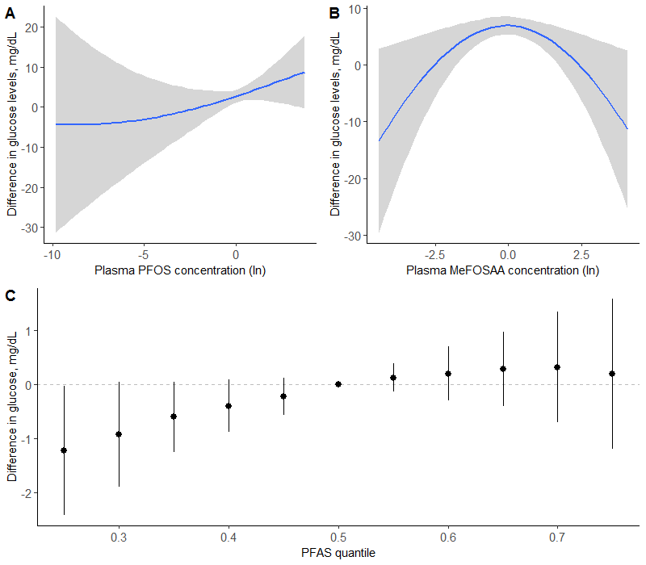

**Figure S2.** Combined effects of the PFAS mixture on blood glucose levels (n=1,533) estimated by Bayesian Kernel Machine Regression (BKMR), adjusting for maternal age (continuous), pre-pregnancy BMI (continuous), prior history of GDM/parity, race/ethnicity, smoking, education. Univariate exposure-response function and 95% confidence bands for (A) PFOS and (B) MeFOSAA holding all other PFAS at the median. (C) Overall effect of the PFAS mixture. This plot shows the estimated difference in blood glucose levels and 95% credible intervals when all PFAS concentrations are held at a certain percentile compared to when PFAS concentrations are held at the median. Abbreviations: PFAS, per- and polyfluoroalkyl substances; PFOS, perfluorooctane sulfonate; PFOA, perfluorooctanoate; PFHxS, perfluorohexane sulfonate; PFNA, perfluorononanoate; EtFOSAA, 2-(N-ethyl-perfluorooctane sulfonamide) acetate; MeFOSAA, 2-(N-methyl-perfluorooctane sulfonamide) acetate.